# Activity Name: Bharat Blockchain Yatra

# Gopi Reddy Kurri - Student - VVIT (VasiReddy Venkatadri Institute ...

# Topic: Bharat Blockchain Yatra 2023

# Date: 6th August 2023.

# Venue : T-Hub , Hyderabad.

# Agenda: Engage in insightful speaker talks, interactive workshops , and dynamic panel discussions. Explore diverse industry veritcals, uncover real-world blockchain use cases, and network with experts.

**Introduction:** The members of our Blockchain Club had the privilege of attending the "Bharat Blockchain Yatra," a significant event in the blockchain and web 3.0 space. This event brought together experts, enthusiasts, and industry leaders to discuss the latest trends, developments, and applications of blockchain technology in India.

**Key Highlights:**

**Speakers**: The event featured a diverse range of speakers, including

1. Chandrasekhar Buddha : Chief coordinating officer AICTE, Ministry of Education , Government.

2. Kamal Youssefi : President Of The Board Of Directors , The Hashgraph Association

3. Kamlesh Nagware : Chief Technology Officer, Snapper Future Tech.

4. Nitin Burman : National Head- Non Subscription Revenue Arha Media & Broadcasting Private Limited.

5. Pallav Bajjuri: Founder IPVerse.

6. Pavan Adipuram: Founding Partner and Chief Executive Officer Pangean Global Services

7. Prashant Kalangi :Founder & CEO TASSETS.

8. Prashanth Swaminathan : Partner Woodstock Fund.

9. Rajesh Dhuddu : SVP & Global Business Head Tech Mahindra.

10. Sairam Vedam : Chief Marketing Officer Cigniti Technologies.

11. Shobu Yarlagadda : Chief Execution Officer Arka Mediaworks Pvt Ltd.

12. Stefan Deiss : Co-Founder & Board Member The Hashgraph Association

13. Sudeep Choudhari : Head India Blockchain , National Payments Corporation Of India(NPCI).

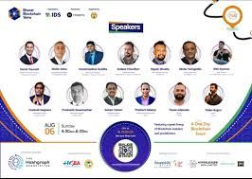

**Summary** :

The curtain raiser event commenced with a remarkable inauguration, led by Sudharshan Reddy Minumula, CEO of IDS, and Voruganti Aravind, Convenor of BBY. Speaking on the occasion, Sudharshan, CEO of IDS said that, we have been pioneers in the enterprise blockchain space, providing cutting-edge blockchain solutions to governments and corporates worldwide across 9 Industry verticals. He extended special thanks to Kamal and Stefan of The Hashgraph Association for being Headline sponsor and supporting this initiative of unprecedented scale. Further, he also thanked Chandrashekar Buddha for all support and encouragement from AICTE, Ministry of Education to make this initiative happen. Aravind Voruganti said that this journey explores the immense potential of blockchain and Web 3 across India. Bharat Blockchain Yatra is a testament to our commitment to fostering blockchain innovation and entrepreneurship in India. Our goal is to not only raise awareness about value-driven blockchain use cases but also provide a platform for companies and startups that have not received the limelight they deserve, he added.

Chandrasekhar Buddha, CCO of AICTE, graced the occasion and launched the **B-ON portal**. Speaking on the occasion, he said that India has biggest advantage of demographic dividend and youth of our country should take the advantage of scaling their startups in emerging technologies like Blockchain. He issued a letter of support to Bharat Blockchain Yatra and Bharat Blockchain Network from AICTE which was received by Aravind Voruganti, Vice President IDS and Sunil Yadavalli, Business Head IDS.

Stefan Deiss from The Hashgraph Association eloquently shared Hedera's profound vision for India's blockchain landscape and unveiled the "Hedera India Hackathon 2023". As part of this initiative, the top three selected startups will each receive up to Rs 2 Crore in grant funding to develop scalable and utility-driven applications on Hedera. He also announced that one representative from each of the chosen companies will embark on an incredible two-week journey to Switzerland, collaborating closely with Hedera's engineering teams which will allow them to gain invaluable insights and expertise from the industry's best, propelling their projects to new heights of success.

The event witnessed multiple expert speaker sessions, panel discussions, product showcases and demonstrations from industry leaders in Web 3.0 space which ignited discussions, collaborations, and ideas that will shape the future of blockchain technology in India. Hyderabad Software Enterprises Association (HYSEA) and The Federation of Telangana Chambers of Commerce and Industry (FTCCI), played a vital role as ecosystem partners. Future Skills Prime and Telecom Sector Skill Council (TSSC) were skilling partners for Bharat Blockchain Yatra while Hyperledger India Chapter, Blockchained India, and Hyderabad DAO have contributed to the event success as community partners.

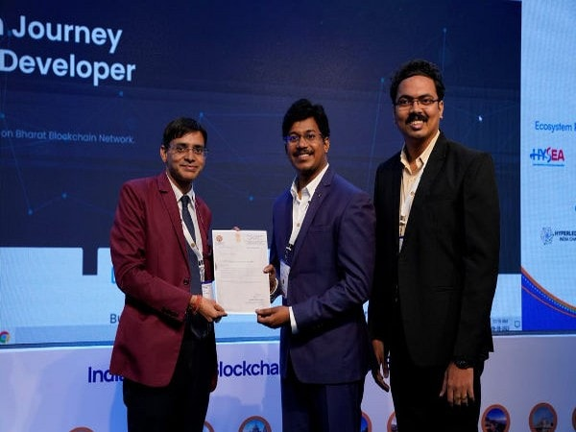

**Our Club’s Involvement**:

Our club members actively participated in various aspects of the event:

1. Attending Sessions: Members attended a wide range of sessions, from introductory talks to advanced technical discussions, broadening their understanding of blockchain technology.
2. Networking: Our members engaged with professionals , industry experts, and fellow enthusiasts, expanding their professional network within the blockchain space

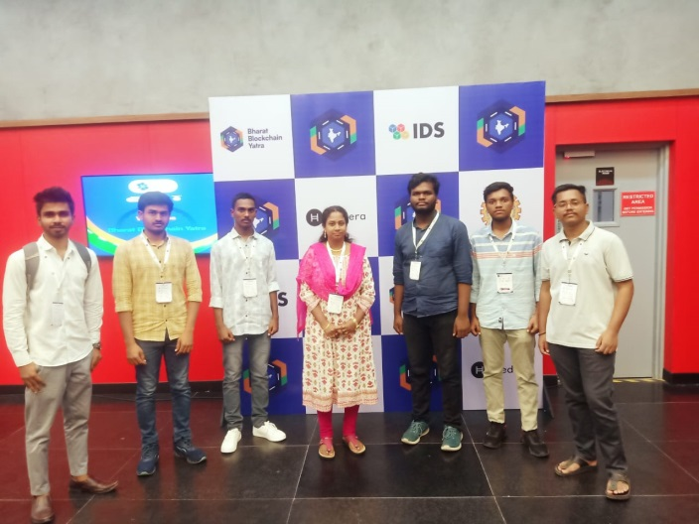 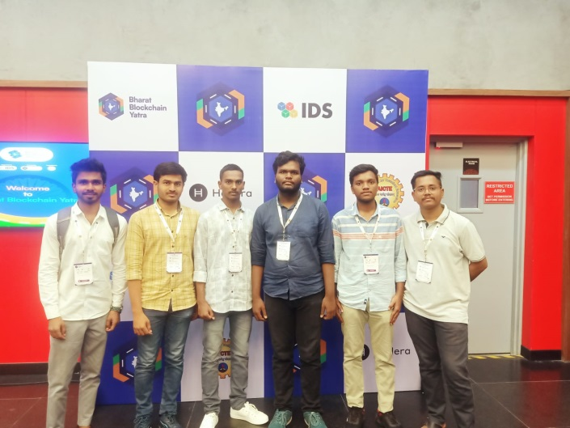

Report by:

Cilivery Nikhil,

President,

Blockchain Club.